**Decision Support System in Smart Healthcare: System for diagnosis of skin cancer using deep learning**

Veronica Angelica Villalobos Romo [0000−0002−8021−5145] and

Edgar Daniel Gomez Garcia [𝑁𝑂𝑇 𝐼𝐸𝑁𝐸𝑂𝑅𝐶𝐼𝐷] and

Claudia Georgina Nava Dino [0000−0002−8714−3690] and

Jose Manuel Mejia Muñoz [0000−0002−5832−6623] and

Jose David Diaz Roman [0000−0002−8246−6562] and

Soledad Vianey Torres Arguelles [0000−0003−0978−3796]

**Abstract** This chapter presents a mobile application as a decision support system for detecting six types of pigmented skin lesions using deep learning. Melanoma, the most aggressive of these conditions, represents only 1% of skin cancer cases but causes most deaths. Early detection is crucial for a higher chance of cure. In low-income countries, insufficient equipment and specialists make early diagnosis challenging. This mobile application aims to address the problem by allowing nonspecialists to make a probable early detection of skin cancer and thus make the decision to consult a medical specialist. The decision support system uses convolutional neural networks with dense layers and applies the SMOTE [1] method to balance the dataset. Evaluations using the HAM10000 and PAD-UFES databases show a classification accuracy of over 80% across six skin cancer classes, with an improvement of up to 9% when SMOTE is applied. The lightweight application (284 MB) processes images directly from the smartphone camera or stored images, achieving a latency of 9.33 seconds per response, allowing the processing of six patients per minute. The proposed system offers significant potential to improve early diagnosis and treatment of skin cancer, particularly in resource-limited settings.

* 1. **Introduction**

Skin cancer has become a global public health issue, with its incidence increasing over the past decades [2, 3]. It is estimated that in 2022, there were 335,000 new cases of melanoma worldwide, and around 60,000 people died from the disease [4]. The morphological characteristics of skin lesions are crucial factors in the diagnosis and early detection of cancer [5]. The skin, the largest organ of the human body, covers between 1.5 and 2 square meters and weighs approximately 4.2 kg [3]. The term “skin cancer” encompasses several neoplasms that share malignant behavior; however, individually they show very diverse degrees of local aggressiveness, tendency to metastasize, and mortality. These differences in malignancy are one of the most distinctive characteristics of skin cancer. The least malignant skin cancer, basal cell carcinoma, develops in the skin, as does one of the most aggressive neoplasms, melanoma. There can be superficial, slow-growing carcinomas to highly destructive invasive tumors capable of metastasizing [2, 3, 5].

The American Cancer Society estimates that approximately 100,350 new cases of melanoma will be diagnosed in the U.S. (about 60,190 men and 40,160 women). Melanoma is considered rare in Mexico, with an incidence of less than one case per 100,000 inhabitants, representing around 2,700 cases annually [6]. However, identifying melanoma is crucial as it has been detected that those susceptible to skin cancer in Mexico include farmers, sailors, street vendors, and individuals with genetic predispositions. Most of these people can be considered low-income, leading to a lower likelihood of early diagnosis and timely treatment [6, 7, 8]. In developing countries like Mexico and Brazil, particularly in peripheral areas, there is a lack of dermatologists and dermatoscopy equipment. Mobile devices can be a useful tool in this situation, given the high number of mobile subscriptions; according to Kassianos et al. [9], there were nearly eight billion subscriptions in 2019.

Numerous works have been proposed for melanoma detection using convolutional neural networks (CNN) on dermoscopic images. However, data imbalance in the available datasets has been a recurring problem, as the classification categories are not equally represented [10, 11]. In the medical field, a significant numerical imbalance in the number of samples of different lesion classes is common [12, 13]. In this context, machine learning has emerged as a powerful tool for medical image classification and disease detection [14, 15, 16, 17].

For example, Dai X. et al. [18] developed a classifier using the HAM10000 database [19], achieving an accuracy of 70%. On the other hand, Castro P. et al. [20] employed the MUPEB balancing technique (Extra-Polarization and Differential Evolution Balancing) with the PAD-UFES database [21], achieving an accuracy of 83%. This result represented a 6% and 16% increase in accuracy and sensitivity, respectively, compared to previous works.

Data imbalance remains a significant challenge in developing effective classification methods. In 2019, R. Gao et al. evaluated the use of the Synthetic Minority Over-sampling Technique (SMOTE) in classifying facial skin pigmentation disorders, confirming a 7% improvement in accuracy for the two classes with the fewest data points [22, 1].

In [23], the SMOTE technique was implemented on imbalanced data from the HAM10000 skin cancer image repositories. Subsequently, a convolutional neural network-based architecture was used to classify seven classes of skin lesions. This approach has the potential to significantly improve accuracy and sensitivity in detecting melanoma and other skin lesions, thereby contributing to earlier and more effective skin cancer diagnosis [23].

* + 1. **Importance of Artificial Intelligence and Data Analytics in Medical Imaging**

In the health sector, artificial intelligence, data analytics, and image processing are fundamental for decision-making, diagnosing, and treating various diseases, representing the most innovative advancements. Through data analysis and advanced technology, it is now possible to detect diseases, initiate immediate treatment, and increase the chances of success [24]. Modern algorithms assist doctors in utilizing everything from Magnetic Resonance Imaging and signal acquisition equipment to laboratory test results, identify patterns and signals that may indicate the presence of a disease. In this way, data analytics facilitates the analysis of large volumes of medical data to improve patient care and medical research [24, 25, 26]. Medical image processing and data analytics enable healthcare professionals to make more precise and personalized diagnoses. According to a study by Saba et al. (2019), the use of deep learning algorithms in medical imaging has significantly improved the ability to detect diseases such as breast cancer and melanoma [25]. Therefore, data analytics helps to manage large amounts of data to convert it into clear and useful information. This allows for more informed decision-making with less risk, as they are based on concrete data. Additionally, leveraging the potential massive amounts of data in the medical field ensures that care is appropriate for the patient and delivered at the right time, being potentially beneficial for everyone involved in the healthcare sector [27]. Artificial intelligence and data analysis are related, although they have different goals and objectives. Artificial intelligence aims to create autonomous and intelligent systems, while data analysis focuses on extracting valuable information from data to support decision-making. Both are important in the information age and are constantly evolving, providing opportunities for development and research in various areas such as the health sector [27].

* + 1. **Skin Cancer and Its Diagnosis**

The detection and diagnosis of skin cancer have traditionally been carried out through visual inspection combined with a systematic evaluation or examination process to identify the disease. However, this depends on the dermatologist’s experience, making the process lengthy, subjective, and possibly prone to errors [28]. This is due to the complex nature of skin lesions. Additionally, diagnosing skin cancer is not just about identifying melanoma or non-melanoma. It also includes multiple skin lesions, which complicates specialized analyses, such as distinguishing a melanocytic nevus from a melanoma or from basal cell carcinoma and squamous cell carcinoma, among other lesions [8]. Consequently, Computer-Aided Diagnosis (CAD) systems become necessary for the preliminary diagnosis of different lesions [29]. The use of deep learning technology with Convolutional Neural Networks (CNN) helps specialists identify and diagnose skin lesions, such as melanoma, more accurately and efficiently, leading to new research and developments to improve the performance of CAD in addressing many other complex clinical problems [29]. Using CAD with CNN provides a powerful tool that supports healthcare professionals in identifying skin lesions, improving diagnostic accuracy, and enabling earlier and more effective interventions. By combining medical expertise with advanced technology, more precise and efficient patient care is achieved [30]. Advances in smartphone cameras have enabled their potential use for the early detection of skin cancer. Smartphones can now recognize characteristics associated with skin cancer. To achieve this, CNN are commonly used for the detection and classification of diseases [31]. However, only a few deep learning models can be utilized to create a mobile application, as they require high computational power and large memory, which is challenging to implement on smartphones [32]. Nonetheless, various studies have developed mobile applications on smartphones with favorable results [30, 31, 32, 33]. Therefore, the development of a mobile application for skin cancer detection is essential, as it offers an accessible and portable tool for users to identify skin problems and seek timely medical attention. Additionally, the presence of a precise and easy-touse diagnostic tool on a common device such as smartphones can significantly reduce the burden on healthcare systems, allowing professionals to provide appropriate treatment for the overall well-being of patients.

* 1. **Methodology**

This section describes the methodology used to create the application that detects skin cancer using images, First, image repositories with clinically diagnosed and classified cases by healthcare professionals were sought. Then, the data were balanced with the SMOTE method, followed by the design of a fully connected dense network with convolutional adjustable base. This network was evaluated using convolutional architectures, two of which were of low-weight and the remaining two were of high weight. These architectures were sourced from the Keras library, and a fine tuning was applied. Then an application based on java language was designed to run on an Android device, and finally the system was simulated with test users to finally evaluate the effectiveness of the application. Figure 1.1 shows a diagram describing the process carried out in this methodology.

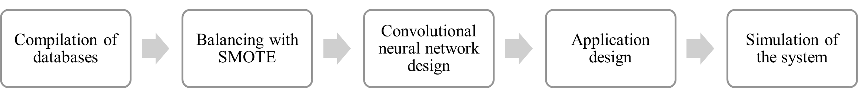

**Fig. 1.1** Methodology process

Each section proposed in the methodology is detailed below.

* + 1. **Compilation of Databases**

Training artificial neural networks to perform classification requires pre-labeled data, meaning each image must have an associate label indicating the class or object it contains. For this reason, the HAM10000 database [19] was optimal for this project. This repository contains images of various types of skin diseases and syndromes, previously classified by healthcare professionals. It consists of 10,015 dermatoscopic images with a uniform size of 1024x1024 in jpg format, which are publicly available. Table 1.1 shows the number of images for each of the classes included in the database.

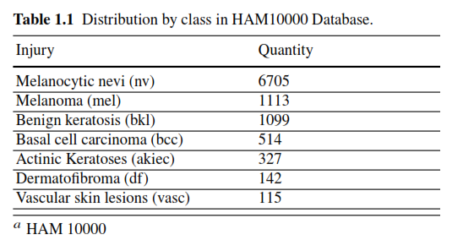

On the other hand, images from the PAD-UFES repository [21] were also used, which contains clinical images of skin lesions properly labeled. The images were acquired with mobile devices and vary in size from 256x256 to 1024x1024 in PNG format. This dataset is an effort to assist researchers in developing low-budget tools, particularly to aid in skin cancer detection. Table 1.2 shows the number of images per class in the PAD-UFES database.

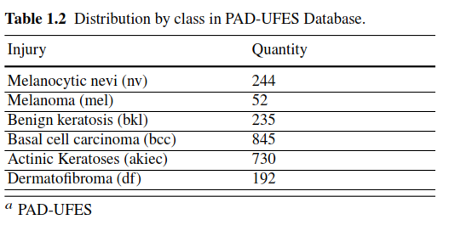

For this work, the vascular lesion class was first eliminated from the HAM10000 database because this lesions are considered skin anomalies rather than pathologies. Subsequently, both databases were concatenated in such a way that when adding all the images from PAD-UFES to HAM1000, 1165 images of melanoma, 1334 of benign keratosis, 1359 of basal carcinoma and 1057 of actinic keratosis were obtained; Since a similar number of images per class is sought, a random undersampling of the nv class was performed. It was to use the 244 images of moles from the PAD-UFES and add them with a random sampling of 956 images from the HAM10000 to result in a final number of 1200 images of moles and thus have a balanced distribution among the above classes of lesions. As for the dermatofibroma class the sum of images from both databases resulted in 307 images. Table 1.3 shows the distribution of images per class after combining both the HAM10000 and PAD-UFES databases.

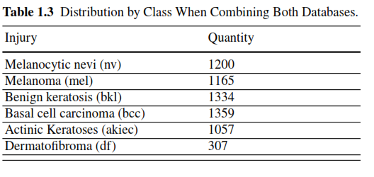

* + 1. **Balancing with SMOTE**

The SMOTE data balancing technique was used only on the dermatofibroma class, because it was the class with the smallest number of images. For this purpose, first the images of two classes were separated in different folders, where in one of them there were the images of the minority class that needed to be balanced, i.e. ”squamous cancer” and in the other one there was a reference class with the number of images to be obtained at the end; the benign keratosis class was used for this purpose. Subsequently, the images of both classes were resized to 256x256 pixels to standardize their dimensions, as the two databases contains images of different sizes. The processing of the data to perform the balancing by SMOTE [34] consisted of the following: the first step is to parameterize the values of each RGB (Red, Green and Blue) combination of the pixels of each image to bring these values to a two-dimensional plane, where each point in this plane represents an image. Next, a random point from the minority class and a random point from the reference class are selected and a new point is generated at half the distance between these two points. This process was repeated until the same amount of data (images) from the minority class was obtained with respect to the reference class. Figure 1.2 shows examples of the results of the false images generated with SMOTE.

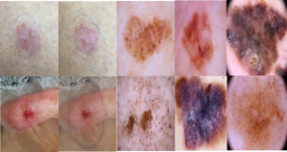

**Fig. 1.2** Fake images generated with SMOTE of the dermatofibroma class.

A total of 804 dermatofibroma images were generated and added to the total image set, resulting in the distribution shown in Figure 1.3. The images were separated in a stratified manner, reserving 20% of all images for the test set, 64% for the trained set, and 16% for the validation set used at the end of each epoch during training. None of the images artificially generate by SMOTE were added to the test set.

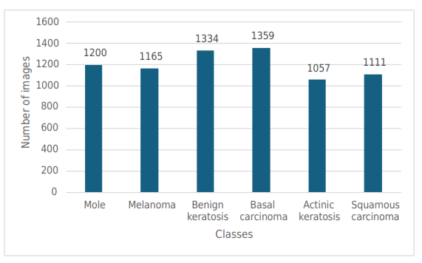

**Fig. 1.3** Histogram of distribution by class after SMOTE.

* + 1. **Convolutional neural network design**

Four convolutional neural network architectures were evaluated: Xception [35], Resnet152V2 [36], EfficientnetV2 [37] and MobilenetV2 [38]. Each of these networks was loaded from the Keras library, using the pre-trained versions with weights predefined by ImageNet challenge [39], subsequently the last default classification layer was removed and the option to train the weights of the convolutional layers was enabled. To adapt each network to our classification task, a “GlobalAveragePooling” follow by a dense layer with six neurons and a SoftMax activation function to classify the six types of lesions in the study.

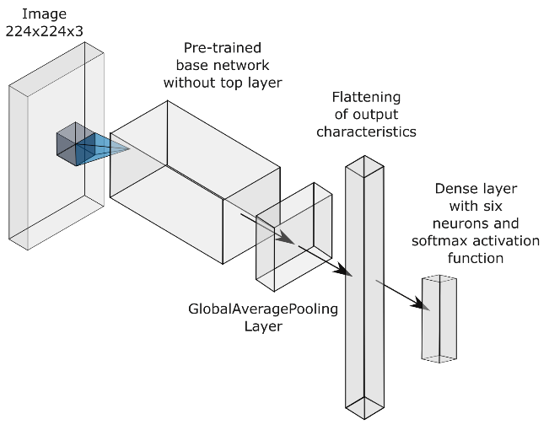**Fig. 1.4** Architecture for

evaluating the design of

convolutional networks.

The architecture described in Figure 1.4 was trained with batch sizes of 64 images for 40 epochs at a learning rate of 0.001 using an Adam optimizer and a categorical cross-entropy loss function. Additionally, a learning rate step-down function was added, along with an early stopping function to halt training if performance did not improve for 5 epochs. After training the four architectures described above and evaluating their performance using the validation set, the EfficietNetV2 convolutional neural network architecture was chosen for its superior performance at this stage. Once the layers were trained as described, the classification layer was removed and dense layers were added to reduce the output features. These layers were sequentially counted with 1280, 1280, 640, 320, and 160 neurons, each with a GELU activation function. DropOut layer with rate of 0.6 was added after each dense layer to prevent overfitting. Finally, a dense output layer with six neurons an a Softmax ativation function was added to perform the classification. Figure 1.5 illustrates the described architecture.

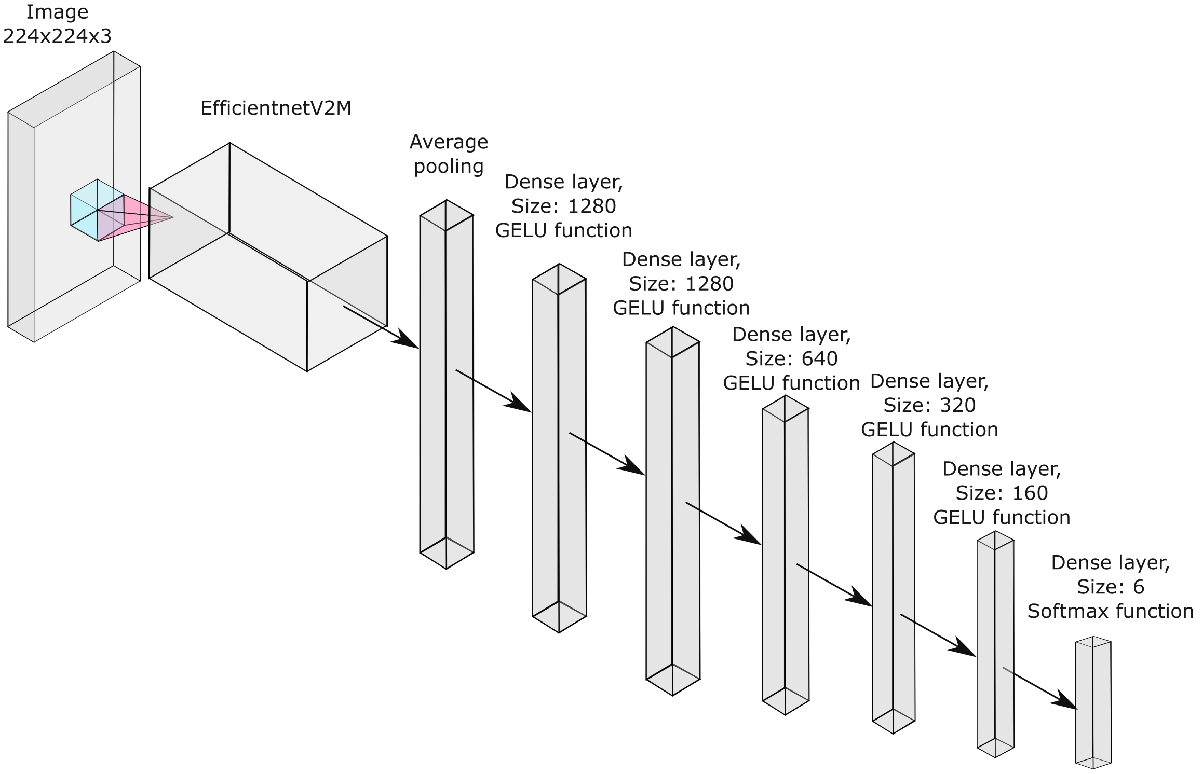

**Fig. 1.5** Network architecture for sorting (each dense layer upstream of the output has DropOut of 0.6)

* + 1. **Application design**

For the design of the application, Android Studio [41] was used, which, in order to interpret keras/tensorflow models, requires them to be in tensorflowlite (tflite) format [42]. This format is lightweight, encrypted in folders and designed to work in applications with low performance equipment such as a cell phone, tablet or microcomputer. Then, the following lines of code were applied to make the change to the tensorflowlite format:

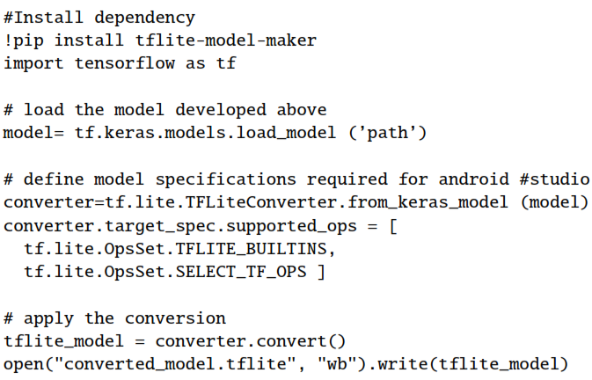

In the previously described program, it is important to highlight that the function ”tf.lite.OpsSet.TFLITE BUILTINS” and ”tf.lite.OpsSet.SELECT TF OPS” allows to perform native operations of the tensorflow library, and although it adds slightly weight, it is necessary to run efficiently in the application developed in Android Studio.

The original model weight is in .h5 format (hierarchical data format), which contains multidimensional arrays of scientific data and has a final memory size of 284 MB; transforming the model to tensorflowlite format reduced its memory to 110.5 MB, which gave the opportunity to add more dense layers and convolution filters to the model without exceeding the 200MB limitation requested by Android studio, however no model showed improvement, so it was determined to keep the model already created for the application. Once the interface was designed, the dependencies for the Android device and the libraries required for the system’s functionality were imported, and the application was installed on the mobile device. The application was originally made in Spanish. The application process is described below: First, the application must be installed on the device, this can be done directly through Android Studio with the help of a USB cable. Once the install option is selected, the mobile device will display the message shown in Figure 1.6, asking for permission to install the software on the device. Next, the installed application will open and the menu shown in Figure 1.7 will be displayed. The user will be presented with two options in the form of buttons to analyze an image: the first option is to acquire an image using the device’s camera, while the second will allow the user to browse its image libraries to select an image if it is preloaded.

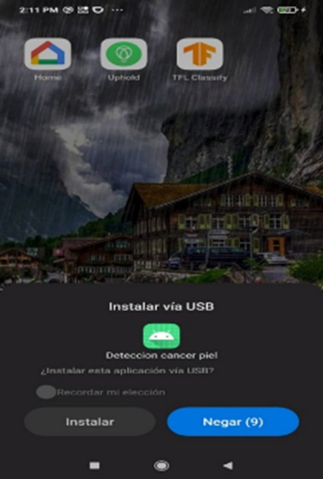**Fig. 1.6** Installation process

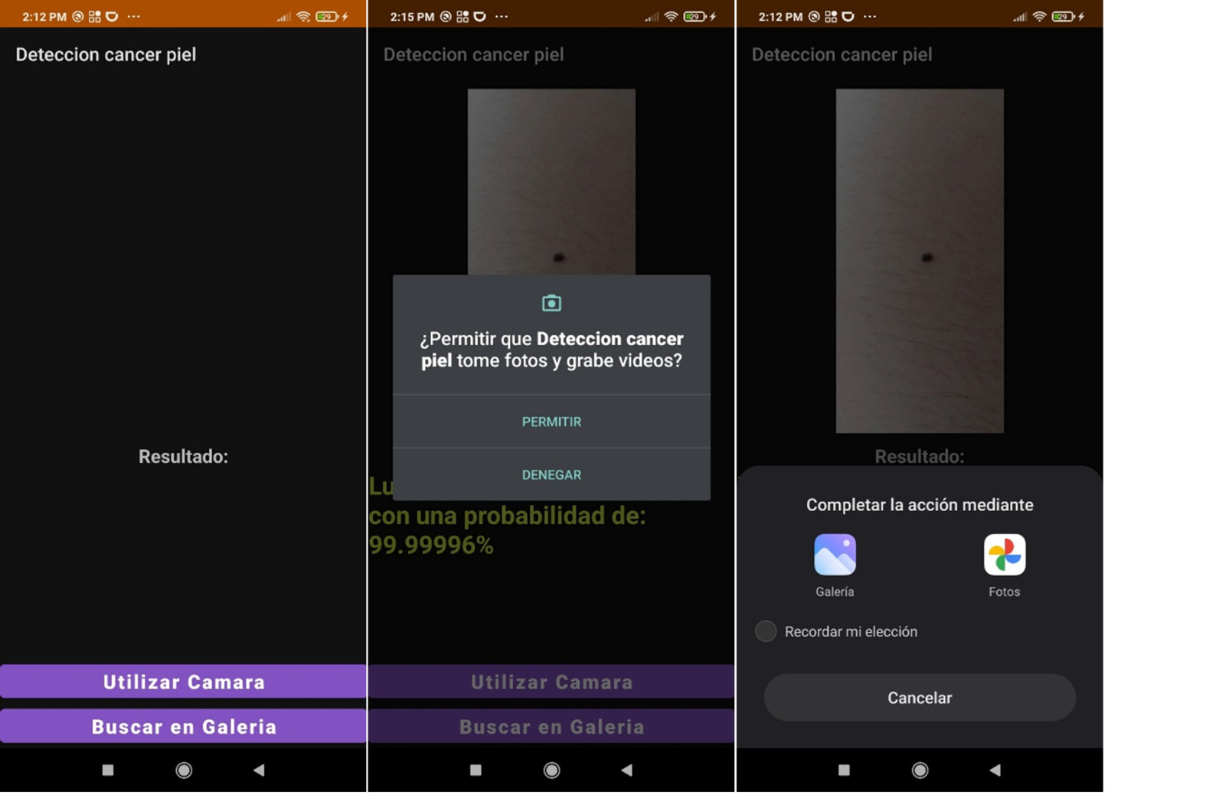

**Fig. 1.7** Application menu and image selection.

* + 1. **Simulation of the system**

Once the image to be analyzed is selected, it will be displayed on main screen, with the classification result given by the model shown below it, together with the probability of this classification with respect to the rest of the 6 classes that can be evaluated. The results visualization in the application is shown below in Figure 1.8. It should be noted that the test shown in this figure was a real evaluation with a test subject, who had the mark observed in the image since birth, so it was indeed a mole.

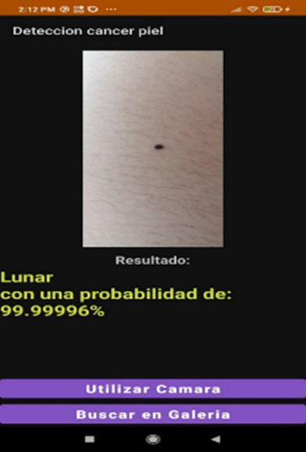**Fig. 1.8** Display of results.

* 1. **Results**

Two experiments were carried out: the first involved training the networks with the original images, and the second used a data set augmented with SMOTE-balanced images of the dermatofibroma class. The training was performed with 100 epochs using a function that decreases the learning rate gradually and another function that stops the training at the moment when the loss metric monitored in the validation set stops improving, this to avoid overfitting to the training data. The results during the training process are shown in Figure 1.9 and 1.10.

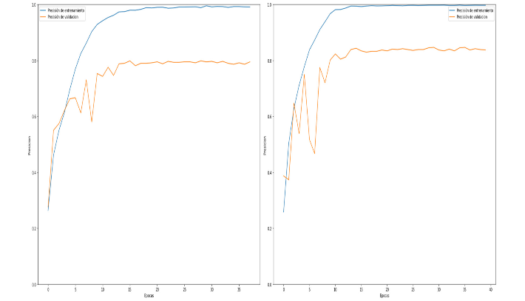

**Fig. 1.9** Accuracy results without SMOTE (left), with SMOTE (right).

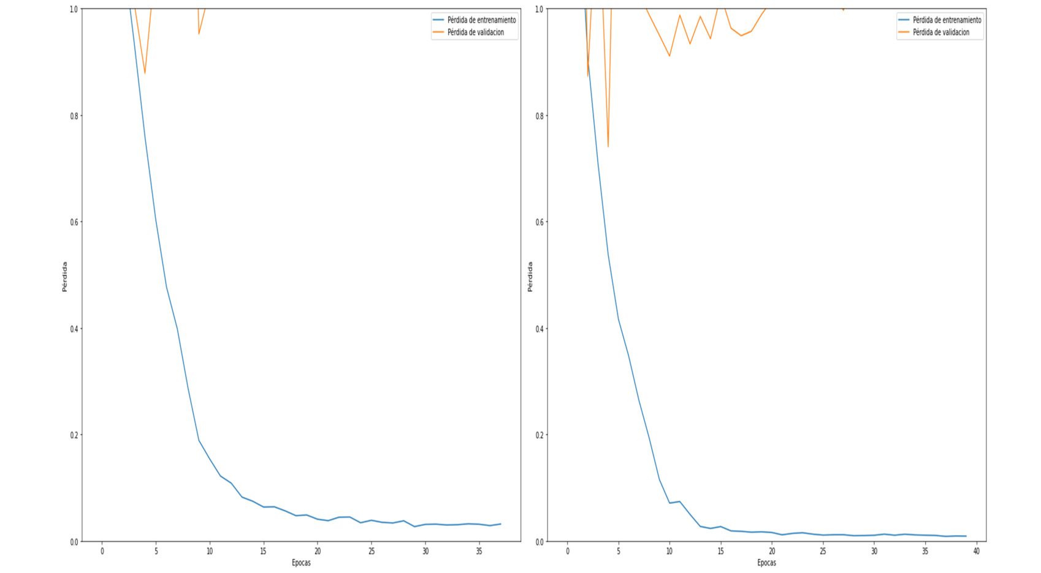

**Fig. 1.10** Loss results without SMOTE (left), with SMOTE (right).

Subsequently, an evaluation was carried out with the final model using the data initially reserved for testing, which did not contain artificial images. To perform this evaluation, a confusion matrix was constructed, and the result are shown in Figure 1.11.

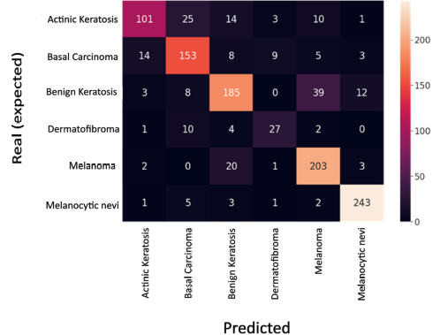

**Fig. 1.11** Validation confusion matrix.

To analyze the performance of accuracy, sensitivity and F1-score for each of the classes, a ranking report was made, as shown in Table 1.4.

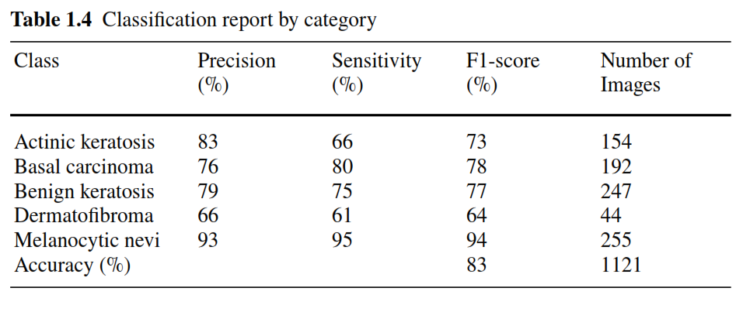

In addition, ROC (Receiver Operating Characteristic) curves [34, 40], were also used for the evaluation. The results of the proposed classifier including the values of the area under the ROC curve are shown in Figure 1.12.

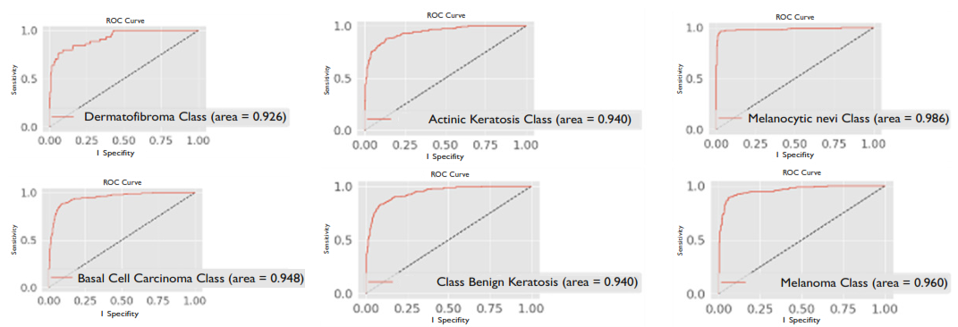

**Fig. 1.12** ROC curve plots for the classification of the different classes of lesions without SMOTE.

Overall global accuracy performance was 73% without SMOTE and 83% with SMOTE, representing a 10% improvement overall. It can be observed from the ROC plots that there is an AUC greater than 92% in each of the classes. As an experiment, the app was evaluated by taking images that are not in the database, taking the image with the cell phone pointing to the computer screen, where a validated sample of each of the classes was presented, the result is shown in Figure 1.13.

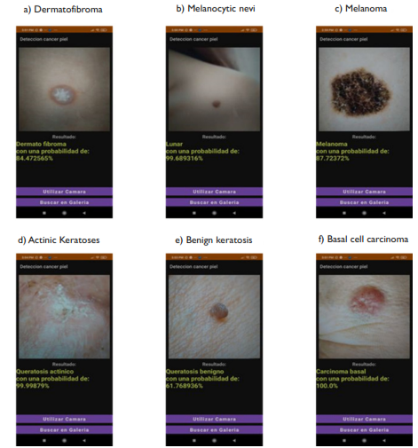

**Fig. 1.13** Test of application using images external to the databases, taken from the computer screen.

Figure 1.13 showed an effective classification response in new data, especially considering that all the evaluations, except item “d”, were correct at the first attempt with low resolution images, without requiring any equipment other than the cell phone. In the case of item “d”, the correct answer was obtained on the second attempt. This may be because the first image evaluated included other elements, such as hair and part of an eye. This result is shown in Figure 1.14.

**Fig. 1.14** Erroneous eval-

uation at the first attempt,

inciting basal carcinoma, actually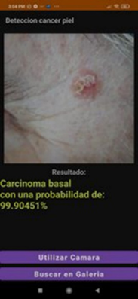

being actinic keratosis.

The average response time when introducing an image to the model in the aplication is 2.35 seconds, the image acquisition time is 6.58 seconds so that on average an express analysis took an time of 9.33 seconds.

* 1. **Conclusions**

SMOTE balancing proved to be a great tool to generate artificial data when there is a scarce amount of data. It was demonstrated that this technique promotes a higher convergence speed when training, in spite of having a higher variance in the training. It was possible to improve the overall performance global accuracy of 73% without SMOTE and 83% with SMOTE, representing an improvement of 10% in general, in addition, it can be concluded from the ROC graphs that there is an AUC greater than 92% in all classes. It was possible to create a low memory model (284MB) and transform it to tensorflowlite format to be applicable to an Android cellular device, reducing its weight to 110.5MB, which showed compatibility and fast response. An on-device application was developed with a simple interface, capable of classifying six different types of skin marks using either the cell phone camera or images from the gallery. The application demonstrated good performance with both syntetic data and real cases of moles, as note in the limitations sections. It exhibited an average latency of 9.33 seconds. Overall accuracy results of 83% were achieved with validation data, which surpasses Dai Xaingfeng’s first approach (accuracy of 72.4%) [18]. The proposed model competes with the application developed by Kousis et al. [33] (91.1% accuracy) for two classes of lesions classified as benign or malignant.; as well as with the approach using a 3D curvature pattern highlighting and convolution technique for melanoma diagnosis 89.2% accuracy by Yu Zhou [43], which requires photometric stereo equipment for its operation. Finally, it is comparable to the model proposed by B. Krohling, et al. [21], based on convolutional networks with evolutionary algorithms making use of data in the patient file, which achieved a final accuracy of 89%. It is important to mention that all the previously mentioned works are only to evaluate the melanoma class in a binary way (positive/negative), while this work presents a solution to classify six different classes, where an F1-score of 83% was achieved in the melanoma class, with a sensitivity of 89%; at the same time the system showed an F1-Score of 94% to identify moles with a sensitivity reaching 95%. It is important to mention the area of opportunity that exists to increase the performance of the model for the identification of the rest of the lesions, whose accuracy values were low, as in the case of dermatofibroma in which only 66% was reached. One way is to explore other neural network architectures and/or models that allow the extraction of relevant features from the images together with the use of other types of classifiers. A cell application was developed, capable of classifuing skin cancer images using a model based on a convolutional architecture. This model achieved an overall accuracy of 83% with test data.

**References**

1. N. V Chawla, K. W. Bowyer, L. O. Hall, and W. P. Kegelmeyer, “SMOTE: Synthetic Minority Over-sampling Technique,” Journal of artificial intelligence research, 16, 321-357 2002.
2. C. Alonso-Belmonte, T. Montero-Vilchez, S. Arias-Santiago, and A. Buend ´ ıa-Eisman, “Situaci ´ on actual de la prevencion del cancer de piel: una revision sistem ´ atica,” Actas Dermosifiliogr, vol. 113, no. 8, pp. 781–791, Sep. 2022, doi: 10.1016/j.ad.2022.04.015.
3. A. Sa´ul, Lecciones de dermatolog ´ ıa, 16a. Mexico: Mc Graw Hill, 2015.
4. IARC, “Melanoma Awareness Month 2022 – IARC.” [Online]. Available via DIALOG: https://www.iarc.who.int/news-events/melanoma-awareness-month-2022/ Cited 17 Oct 2022
5. P. C. Gameros and J. Eljure Tellez, “El cancer de piel, un problema actual,” Revista de la Facultad de Medicina de la UNAM, Ciudad de Mexico, pp. 6–14, Jan. 11, 2016.
6. A. C ´ amara-Salazar et al., “Caracterısticas individuales y por entidad federativa de la mortalidad por melanoma en M ´ exico entre 2014 y 2018,” Dermatol Rev Mex, pp. 248–254, May 2020
7. R. Roldan, ”C ´ ancer de piel, el segundo m ´ as frecuente en M ´ exico, advierte investigador de la UNAM,” UNAM, 2017. [Online]. Available via DIALOG.: https://www.dgcs.unam.mx/boletin/bdboletin/2017 237.html. Cited 18 Oct 2020
8. R. R. Mar ´ ın and B. C. Ortega, “Criterios dermatosc ´ opicos para el diagn ´ ostico de lesi ´ on melanocıtica y melanoma cutaneo Dermoscopic criteria for the diagnosis of melanocytic lesions and cutaneouos melanoma,” Dermatologıa Cosmetica, M ´ edica y Quir´urgica, pp. 142–148, 2014.
9. A. P. Kassianos, J. D. Emery, P. Murchie, and F. M. Walter, “Smartphone applications for melanoma detection by community, patient and generalist clinician users: A review,” British Journal of Dermatology, vol. 172, no. 6, pp. 1507–1518, Jun. 2015, doi: 10.1111/bjd.13665.
10. M. A. Al-Asadi and A. Altun, “Deep learning with SMOTE techniques for improved skin lesion classification on unbalanced data,” Selcuk University Journal of Engineering Sciences, vol. 21, no. 03, pp. 97–104, 2022
11. O. O. Abayomi-Alli, R. Dama ˇ sevi ˇ cius, S. Misra, R. Maskeliunas, and A. Abayomi-Alli, “Malignant skin melanoma detection using image augmentation by oversampling in nonlinear lower-dimensional embedding manifold,” Turkish Journal of Electrical Engineering and Computer Sciences, vol. 29, pp. 2600–2614, 2021, doi: 10.3906/elk-2101-133.
12. C. C. Chang, Y. Z. Li, H. C. Wu, and M. H. Tseng, “Melanoma Detection Using XGB Classifier Combined with Feature Extraction and K-Means SMOTE Techniques,” Diagnostics, vol. 12, no. 7, Jul. 2022, doi: 10.3390/diagnostics12071747.
13. X. Tong, J. Wei, B. Sun, S. Su, Z. Zuo, and P. Wu, “Ascu-net: Attention gate, spatial and channel attention u-net for skin lesion segmentation,” Diagnostics, vol. 11, no. 3, Mar. 2021, doi: 10.3390/diagnostics11030501.
14. K. Shehzad et al., “A Deep-Ensemble-Learning-Based Approach for Skin Cancer Diagnosis,” Electronics 2023, Vol. 12, Page 1342, vol. 12, no. 6, p. 1342, Mar. 2023, doi: 10.3390/ELECTRONICS12061342.
15. S. M. Thomas, J. G. Lefevre, G. Baxter, and N. A. Hamilton, “Interpretable deep learning systems for multi-class segmentation and classification of non-melanoma skin cancer,” Med Image Anal, vol. 68, Feb. 2021, doi: 10.1016/j.media.2020.101915.
16. S. Jinnai, N. Yamazaki, Y. Hirano, Y. Sugawara, Y. Ohe, and R. Hamamoto, “The development of a skin cancer classification system for pigmented skin lesions using deep learning,” Biomolecules, vol. 10, no. 8, pp. 1–13, Aug. 2020, doi: 10.3390/biom10081123.
17. M. Vidya and M. V Karky, “Skin Cancer Detection using Machine Learning Techniques,” IEEE International Conference on Electronics, Computing and Communication Technologies (CONECCT)CONNECT, pp. 1–5, 2020.
18. X. Dai, I. Spasi ´ c, B. Meyer, S. Chapman, and F. Andres, “Machine Learning on Mobile: An On-device Inference App for Skin Cancer Detection,” 2019 Fourth International Conference on Fog and Mobile Edge Computing (FMEC), pp. 301–305, 2019.
19. P. Tschandl, C. Rosendahl, and H. Kittler, “Data descriptor: The HAM10000 dataset, a large collection of multi-source dermatoscopic images of common pigmented skin lesions,” Sci Data, vol. 5, pp. 1–9, 2018, doi: 10.1038/sdata.2018.161.
20. P. Castro, B. Krohling, A. G. Pacheco, and R. A. Pacheco,“An app to detect melanoma using deep learning: An approach to handle imbalanced data based on evolutionary algorithms,” in In 2020 International Joint Conference on Neural Networks (IJCNN) , IEEE, 2020, pp. 1–6.
21. A. G. C. Pacheco and R. A. Krohling, “The impact of patient clinical information on automated skin cancer detection,” Comput Biol Med, vol. 116, Jan. 2020, doi: 10.1016/j.compbiomed.2019.103545.
22. R. Gao, J. Peng, L. Nguyen, Y. Liang, S. Thng, and Z. Lin, “Classification of Non-tumorous Facial Pigmentation Disorders Using Deep Learning and SMOTE.” In 2019 IEEE International Symposium on Circuits and Systems (ISCAS) (pp. 1-5). IEEE.
23. S. Guo, Y. Liu, R. Chen, X. Sun, and X. Wang, “Improved SMOTE Algorithm to Deal with Imbalanced Activity Classes in Smart Homes,” Neural Process Lett, vol. 50, no. 2, pp. 1503–1526, Oct. 2019, doi: 10.1007/s11063-018-9940-3.
24. J. Bobulski and M. Kubanek, “Big data system for medical images analysis,” in Frontiers in Artificial Intelligence and Applications, IOS Press BV, Dec. 2020, pp. 71–79. doi: 10.3233/FAIA200768.
25. L. Saba et al., “The present and future of deep learning in radiology,” European Journal of Radiology, vol. 114. Elsevier Ireland Ltd, pp. 14–24, May 01, 2019. doi: 10.1016/j.ejrad.2019.02.038.
26. M. M. Mijwil et al., “View of From Pixels to Diagnoses Deep Learning’s Impact on Medical Image Processing-A Survey,” Wasit Journal of Computer and Mathematics Science, vol. 2, no. 3, pp. 9–15, 2023.
27. S. Dash, S. K. Shakyawar, M. Sharma, and S. Kaushik, “Big data in healthcare: management, analysis and future prospects,” J Big Data, vol. 6, no. 1, Dec. 2019, doi: 10.1186/s40537-0190217-0.
28. A. Adegun and S. Viriri, “Deep learning techniques for skin lesion analysis and melanoma cancer detection: a survey of state-of-the-art,” Artif Intell Rev, vol. 54, no. 2, pp. 811–841, Feb. 2021, doi: 10.1007/s10462-020-09865-y.
29. H. P. Chan, L. M. Hadjiiski, and R. K. Samala, “Computer-aided diagnosis in the era of deep learning,” in Medical Physics, John Wiley and Sons Ltd, Jun. 2020, pp. e218–e227. doi: 10.1002/mp.13764.
30. T. Kr ¨ anke, K. Tripolt-Droschl, L. R ¨ od, R. Hofmann-Wellenhof, M. Koppitz, and M. Tripolt, “New AI-algorithms on smartphones to detect skin cancer in a clinical setting—A validation study,” PLoS One, vol. 18, no. 2 February, Feb. 2023, doi: 10.1371/journal.pone.0280670.
31. C. A. Hartanto and A. Wibowo, “Development of Mobile Skin Cancer Detection using Faster R-CNN and MobileNet v2 Model,” in En 2020 7th International Conference on Information Technology, Computer, and Electrical Engineering (ICITACEE). IEEE, 2020, pp. 58–63.
32. J. O. Emuoyibofarhe, D. Ajisafe, R. S. Babatunde, and M. Christoph, “Early Skin Cancer Detection Using Deep Convolutional Neural Networks on Mobile Smartphone,” International Journal of Information Engineering and Electronic Business, vol. 12, no. 2, pp. 21–27, Apr. 2020, doi: 10.5815/ijieeb.2020.02.04.
33. I. Kousis, I. Perikos, I. Hatzilygeroudis, and M. Virvou, “Deep Learning Methods for Accurate Skin Cancer Recognition and Mobile Application,” Electronics (Switzerland), vol. 11, no. 9, May 2022, doi: 10.3390/electronics11091294.
34. J. Brownlee,” SMOTE for Imbalanced Classification with Python,” Machine Learning Mastery, [Online]. Available via DIALOG: https://machinelearningmastery.com/smoteoversampling-for-imbalanced-classification/. Cited 17 Mar 2021
35. F. Chollet,” Xception: Deep learning with depthwise separable convolutions,” in Proceedings of the IEEE Conference on Computer Vision and Pattern Recognition, 2017, pp. 1251-1258.
36. K. He, X. Zhang, S. Ren and J. Sun, ”Deep Residual Learning for Image Recognition,” 2016 IEEE Conference on Computer Vision and Pattern Recognition (CVPR), 2016, pp. 770-778, doi: 10.1109/CVPR.2016.90.
37. B. Koonce and B. E. Koonce, Convolutional Neural Networks with Swift for TensorFlow: Image Recognition and Dataset Categorization, New York, NY, USA: Apress, 2021, pp. 109-123.
38. Sinha, D., El-Sharkawy, M. (2019). Thin mobilenet: An enhanced mobilenet architecture. In 2019 IEEE 10th annual ubiquitous computing, electronics mobile communication conference (UEMCON). IEEE, 3, 0280-0285.
39. M. A. Morid, A. Borjali, and G. Del Fiol,” A scoping review of transfer learning research on medical image analysis using ImageNet,” Computers in Biology and Medicine, vol. 128, 2021, Art. no. 104115.
40. J. A. Swets, Signal Detection Theory and ROC Analysis in Psychology and Diagnostics: Collected Papers, 1996, Psychology Press, <https://doi.org/10.4324/9781315806167>
41. A. Studio, ”Android Studio: The Official IDE for Android,” 2017. [Online]. Available: https://developer.android.com/studio/. [Accessed: Jun. 24, 2019].
42. S. Li, ”TensorFlow Lite: On-device machine learning framework,” Journal of Computer Research and Development, vol. 57, 2020, p. 1839.
43. Y. Zhou, M. Smith, L. Smith, A. Farooq, and R. Warr, ”Enhanced 3D curvature pattern and melanoma diagnosis,” Computerized Medical Imaging and Graphics, vol. 35, no. 2, pp. 155-165, 2011.